An STE-based methodology for constructing Bayesian Belief Networks as applied to the prediction of Economic Indicators

Fernando Torre
Computer Science Dept.
University of Missouri
MO, USA

Chanmann Lim
Computer Science Dept.
University of Missouri
MO, USA

Adil Al-Azzawi
ECE Dept.
University of Missouri
MO, USA

Abstract—This electronic document is a “live” template and already defines the components of your paper [title, text, heads, etc.] in its style sheet. *CRITICAL: Do Not Use Symbols, Special Characters, or Math in Paper Title or Abstract. (Abstract)
Keywords—component; formatting; style; styling; insert (key words)

Introduction
Although methods exist to construct Bayesian networks using expert knowledge (Russell and Norvig), genetic algorithms (Shapcott et al.), and topological ordering (Chickering and Heckerman) few methods exist to construct a Bayesian network using purely mathematical relations between the variables (Cooper and Herskovits). We believe such a method to be an important contribution to the field, for which reason we set out to develop it.
We based our method on the standard error for a least-squares linear regression, or STE (Microsoft). This metric is consistent with the correlation coefficient and has the additional advantage of allowing us to test causation (Zady). This, combined with minimal domain knowledge, allows us to define an unambiguous, valid Bayesian network.
To test our method, we set out to apply it to the problem of predicting economic growth. This problem not only has a large number of variables on which to build on, but it has also become particularly important in the past eight years given the considerable slowdown that has occurred in the global economy. Policy-makers have been faced with significant budgetary challenges.
Having had to choose which sector has its funding reduced is non-trivial: policy-makers face deadlock and trade-off to arrive at an effective decision in a timely manner. Often, the negative consequences of these changes are greater than their benefits, such as when education funding is reduced, and the effect has been different in every country.
Worldwide, UNESCO has largely led the fight on preventing education funding from being cut. The 2010 report had the explicit aim to “develop public and policy awareness” on the “social and economic” importance of preparing engineers. A recent article (Rayke) shows these cuts are still necessary at the state level, and the ultimate decision taken by policy makers have noticeable effects on polls, and hence, on elections. More-often-than-not, any decision made tends to lead to criticism in different magnitude
The question ultimately boils down to how important each of these factors is. Our Bayesian Network aims to show such how significant these factors are to economic growth. We select a series of variables that measure
- macroeconomic growth.
- industry and commerce.
- Incentives and investment.
- education and academia.
- innovation and research.
We will relate them using STE to create a network, establishing a link where a strong relation is found, and discarding the links that contradict domain knowledge. We will then train and test the networks against the data from the variables using cross-validation.
The next section explains in greater detail the problem of economic growth. Section 3 describes previous work, both in computing factors of economic growth, and in developing Bayesian Network construction methodologies. Section 4 details our approach to the problem of economic growth prediction. Section 5 goes into our Bayesian Network construction methodology. We conclude describing the challenges we expect to encounter during this project.

Background Theory
The global economy is in trouble. Global GDP has been generally falling for nearly a decade (see Fig.1). Governments worldwide and investors have been forced to cut back on spending (UNESCO), reducing the strength of the actors that have traditionally been expected to spur economies (Drahokoupil). A return to the year-to-year growth observed prior to the Great Recession is desirable (the Great Recession can be observed between the years 2007–2009 in Fig.1). This would indicate a return to a global economy capable of withstanding events such as the Asian Financial Crisis (1997–1999 in Fig.1) and the dot-com crash (2001–2003 in Fig.1) without affecting the overall global trend. However, such a strengthening does not seem likely under current conditions. It is only natural for the global question to be how to achieve this.
Fig.1: Percentage of growth in worldwide Gross Domestic Product per capita based on Purchasing Power Parity. The percentage yi-yi-1yi-1 is shown with a solid line. The trend (as given by an ordinary linear regression on the years covered) is shown with a dotted line.
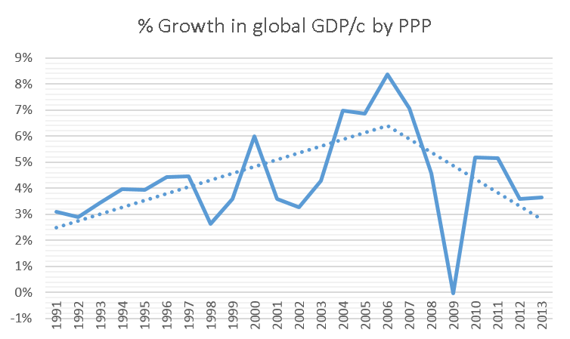
Recent research has shown that investment in education and technology would be extremely favorable to economic growth. As Irina Bokova said in a 2010 UNESCO report,
“The current economic crisis presents challenges and opportunities for engineering. There are encouraging signs that world leaders recognize the importance of continuing to fund engineering, science and technology[. This investment] may provide a path to economic recovery and sustainable development.”
A country’s economic growth has been proven to depend strongly on the number of experts that country has in several areas. (Jaffe et al.; Mora et al.) Specifically, economic growth depends on the knowledge gained by these persons that can be used to manufacture goods, perform services, and improve the productivity of existing process. This knowledge is known as “productive knowledge” (Hausmann et al.; UNESCO) and is usually a subset of the knowledge gained by these persons in their higher education studies, or new knowledge generated by them. Therefore, we can measure productive knowledge, and thereby the effect of higher education on the economy, by comparing the number of graduates in different areas, and the research they perform.
However, the exact weight of productive knowledge in comparison to more traditional factors such as government spending and foreign investment (Drahokoupil) has never been quantitatively assessed. Detriments of favoring any one factor exclusively, are well known (ITEP), but the strength of the influence is observed through trial and error, if it is assessed at all.
In this project, we posit that the Bayesian interpretation of conditional probability is a good measure of this influence. To this end, we will construct a bayesian network to predict three economic indicators from five industry indicators, three investment indicators, five education indicators and five innovation indicators.

Previous work
Much has been published linking different economic and education variables to economic growth. In recent years, research has shown that economic development depends strongly on the number of engineers (UNESCO; Mora et al.), scientists (UNESCO; Hausmann et al.; Jaffe et al.), researchers (UNESCO; Jaffe et al.), and experts in technology (Jaffe et al.) While the existence of a strong relation cannot be denied, none of these studies have measured the strength of this link compared to other possible factors.
Procedures for constructing Bayesian networks, however, are scant (Cooper and Herskovits). The most basic method (Russell and Norvig; Chickering and Heckerman) consists of the arrangement of variables in cause and effect ordering and the exploitation of conditional independence assumption such that Chain rule can be applied to form the conditional probability table.
Methodologies have been developed to construct Bayesian networks for specific purposes, mainly using genetic algorithms (Helman et al.; Shapcott et al.; Cooper and Herskovits). Comparing variables using purely their statistical properties has been done previously using the “mutual information” measure of dependence; however, as Friedman et al. point out, this approach does not seek to optimize any statistical. Friedman attempts to introduce an external optimization metric, but notes that it is computationally intensive. In our approach, the variables are compared with a measure of dependence based on an optimized square error .

Proposed Solution
Our Bayesian network construction methodology is based on the standard error for a least-squares linear regression or STE (Microsoft; Mora et al.). Said statistical is known to be consistent with the correlation coefficient and gives more information than it. The formula for STE is shown below.
STE(X,Y)=(1/(n-2))-{ 
where X is the sample means of X, n=|X|=|Y|, X is the variable presumed independent, and Yis the variable presumed dependent on X. Because STE(X,Y)gives a value in the range [-Y,Y], it is necessary to normalize it. To make it more human-readable (and allow us to set cutoff points easily), we subtract 1 from it. This yields the following formula from Mora et al.:
STE’(X,Y)=1-(STE(X,Y)/Y’) 

A small STE (close to 0), and therefore a large STE’ (close to 1), implies a strong causative relation between X and Y—I.E. Y depends on X (Zady).
We compare every relevant pair of parameters (see section 4.2) using this metric to determine whether a cause-effect relationship exists between them (we will call this “dependence analysis”). A cause-effect relationship between X and Y, with X being the cause of Y, will be taken to exist if STE’(X,Y)>STE’(Y,X), in which case, we add an arc from X to Y. The resulting network will then trained normally as any Bayesian network.

Selected parameters
We selected the following parameters from the World Bank data bank. We present them grouped into three categories given by domain knowledge. Each parameter is shown with its World Bank name.

Economic Indicators

GDP growth (annual %)

GNI growth (annual %)

Economic complexity Index.

Industry and commerce Indicators

Agriculture, value added (% of GDP).

Exports of goods and services (% of GDP).

Imports of goods and services (% of GDP).

Industry, value added (% of GDP).

Services, etc., value added (% of GDP).

Incentives and Investment

Foreign direct investment, net inflows (BoP, current US$).

Net Development Assistance received per capita (current US$).

General government final consumption expenditure (% of GDP).

Education Indicators

Graduates in engineering, manufacturing and construction. Tertiary. Total

Graduates in science. Tertiary. Total

Total graduates in all programmes. Tertiary. Total

Literacy rate, adult total (% of people ages 15 and above).

Primary completion rate, total (% of relevant age group).

Innovation Indicators

Researchers in R&D (per million people).

Scientific and technical journal articles (per million people).

Technicians in R&D (per million people).

Patent applications, residents (per million people).

Trademark applications, direct resident (per million people).

We will use the data from all 180 countries in the World Bank for all the years that data is available for them. Thus, a parameter like GDP, which has 50 years on record, will have 9,000 data points.

Domain knowledge
Previous work has shown that relationships between these broad categories is known: Education affects Innovation and Industry (UNESCO; Jaffe et al.; Mora et al.); Innovation, Industry, and Investment affect the Economy (Drahokoupil; Hausmann et al.). Education is known to not have a direct effect on the economy due to the necessity of applying productive knowledge to Innovation and Industry for its effects to become visible (UNESCO; Hausmann et al.).
To make the approach generalizable, we represent the domain knowledge as a three-layer structure (Fig. 2). Under this model, the variables in the top layer are expected to have an influence on the variables in the middle layer, and the variables in the middle layer are expected to have an influence on the variables in the bottom layer. This can readily be applied to other domains by simply changing the variables involved.
Fig.2: Three-layer structure representing the domain knowledge
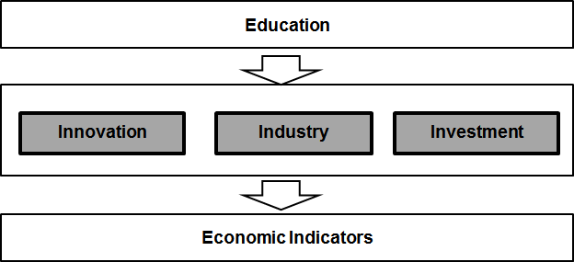
Modelling the domain knowledge also allows us to delimit the number of STE values we would have to calculate. If we were to compare all variables against all others, we would need to perform 21! comparisons, or calculate 2 Quintillion STE values. Following the three layer structure, we only have to compute around 288 STE values.

Determination of Causality
To determine whether a causal relationship X→Y exists, we demand not only that STE’(X,Y)>STE’(Y,X), we also demand that the suggested link does not violate the domain knowledge. This makes intuitive sense: if X is the number of goods produced an Y is how many of those goods were actually sold, we cannot accept a Dependence analysis result of Y→X: the number we eventually sell cannot affect how many we originally produced. In these cases we discard the Dependence analysis result, and simply add no arc at all to the Bayesian network. This means that all arcs created will be oriented from the top-most layer to the bottom-most, which provides the added benefit of ensuring the Bayesian network is acyclic, and hence, valid.
As an example, let us consider a simplified case where there are only two variables: the number of graduates in engineering (Graduates) and the Gross Domestic Product (GDP). We know that Graduates influences GDP, however indirectly so our layer structure should look like Fig.3. We perform the dependence analysis for for Saudi Arabia (Table.1) using data from the World Bank.
Fig.3: Domain knowledge structure for the example
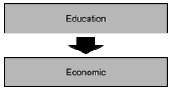
When we assume Graduates to be the independent variable (x) and GDP to be the dependent variable (y), STE’(X,Y)=0.926. However, when we assume Graduates to be the dependent variable (y) and GDP to be the dependent variable (x), STE’(X,Y)=0.713. Because the relation Graduates→GDP is stronger than the relationship GDP→Graduates, we should accept that GDP depends on Graduates. Further, we see that this agrees with our domain knowledge, since Graduates is a top-layer variable and GDP is a bottom-layer variable. Therefore, we add an arc from Graduates to GDP in the Bayesian network.
    - STEYXY:
    - Dependency: To ccomputes the degree of the dependency that y has on x. pseudo code of the dependency function is described below.
Function DEPENDENCY (x,y) output result
Inputs:
Y ← column vector (believed to be caused by X )
X ← column vector (believed to be the cause of Y)
Outputs:
d_y_from_x ← degree (y depends on x)
d_x_from_y ← degree (x depends on y)
End

    - dependency_table: To compute whether a set of variables can be considered to depend on another as given by their dependency values. Were the input is the V - Table of dependency values. Each row is one of the variables to determine, while each pair of columns represents one of the variables with which a dependency relation could exists. Each pair of columns is taken to be ordered as the value for the desired relation first, then the alternative dependency.
For example, to see if A depends on any of the variables in a set B and B depends on c, the table would have to be in the following form:
 | a from b | b from a | b from c | c from b
b1
b2

Function Dependency_table (V, threshold, minimum) output Inputs:
minimum ← depends on how many arcs we dsire
V ← Dependency_Table(bn{var1[],var2[])
threshold ← >.5
Outputs:
T ← Dependency_Table(bn{var1[],var2[])={True,False}
for each row
for each column
row ← T.Properties.RowNames(row);
desired ← V.Properties.VariableNames(col);
alternative ← V.Properties.VariableNames(col+1);
T(row, desired) ← STE.depends_on_TF;
end
end
End

    - dependency_values: To compute the degree of dependency between each of the ROW variables and each of the COLUMN variables. The resulting table has the form.
 | C1 to R | R to C1
R1
R2

Function Dependency_values (RowNames, RowVars, ColNames, ColVars, ColPrecedence Return result
Inputs:
RowNames ← Cell array (row)
RowVars ← Cell array (column vector)
ColNames ← Cell array (row variables)
ColVars ← Cell array (column vector)
Outputs:
assert(length(RowNames) == length(RowVars));
assert(length(ColNames) == length(ColVars));
assert(nargin<5 || length(ColNames) == length(ColPrecedence));
for i←1:length(ColNames)
j← (i-1)*2+1;
if (nargin<5 || ColPrecedence(i))
VariableNames(j) ← char(ColNames(i)), '_to_var' )
VariableNames(j+1) ← 'var_to_', char(ColNames(i))
else
VariableNames(j+1) ← char(ColNames(i)), '_to_var'
VariableNames(j) ← 'var_to_', char(ColNames(i))
end
end

End

    - depends_on function: DEPENDS_ON returns whether y depends on x. Any row with a missing value (nan) in either vector will cause the corresponding cell in the other to be omitted from the analysis.
The threshold which is difference below which the possibility is accepted. This value is taken as proportional to the means of y. E.g.: if the threshold is 0.1 and the dependency analysis returns that Y depending on X would cause an error of .3 times the mean (STE dependency of 70%), while X depending on Y would cause an error of .1 (STE dependency of 90%), the function returns false because the difference is greater than .1. However, if the error of X dependin on Y would be of .25 (STE dependency of 75%) the function returns true _even though_ the dependency of X on Y is greater than Y on X. In short, the threshold is the range in which the values are considered to be "close enough". If no threshold is specified, hard inequality (strictly less than) is enforced.
To computer the minimum which is the value at which the possibility is discarded. This value is taken as proportional to the means of y. I.e.: if the minimum is 0.5 and the dependency analysis returns that Y depending on x would cause an error >0.5 times the means, the function immediately returns false.
Function ( y, x, threshold, minimum ) Return result
Inputs: d_y_x - degreee dependency of Y on X
d_x_y - degreee of dependency of Y on X
Output ← True or Flase
if (~isnan(d_y_x) && ~isnan(d_x_y))
if (nargin >=4 && d_y_x<minimum)
outpout ← false;
else
if(d_y_x > d_x_y)
out ← true;
else
if(nargin < 3)
output ← false;
else
output ← (abs(d_y_x - d_x_y) < threshold);
end
end
end
else
output ← false;
end

    - depends_on_TF function: DEPENDS_ON_TF function returns TRUE or FALSE, making the decision on whether the degrees are different enough that dependency should be considered. If either degree is NAN, the function immediately returns FALSE.
Function Depends_on_TF ( y, x, threshold, minimum ) Return result
Inputs: d_y_x - degreee dependency of Y on X
d_x_y - degreee of dependency of Y on X
Output ← True or Flase
if (~isnan(d_y_x) && ~isnan(d_x_y))
if (nargin >=4 && d_y_x<minimum)
outpout ← false;
else
if(d_y_x > d_x_y)
out ← true;
else
if(nargin < 3)
output ← false;
else
output ← (abs(d_y_x - d_x_y) < threshold);
end
end
end
else
output ← false;
end
Table.1 : Dependence Analysis for Saudi Arabia data (1999-2010)
 | y: Graduates in Engineering | y: GDP per capita (constant intl. $)
x: Graduates in Engineering | 100% | 92.6%
x: GDP per capita (constant intl. $) | 71.3% | 100%

Expected results
Given that the data is temporal, this procedure tells us how to build only one moment in time. A complete model would need to be a time series, as shown in Fig. 4. Bayesian networks will be trained to learn the conditional probabilities. The resulting Bayesian network should be able to predict the economic indicators for any given year, for a given country, given the other variables.

Innovation
Our main contribution to the field lies in our methodology, which is summarized in Fig.5. This methodology is fully automatable and can be adapted to any domain.
Fig.4.Potential resulting bayesian network
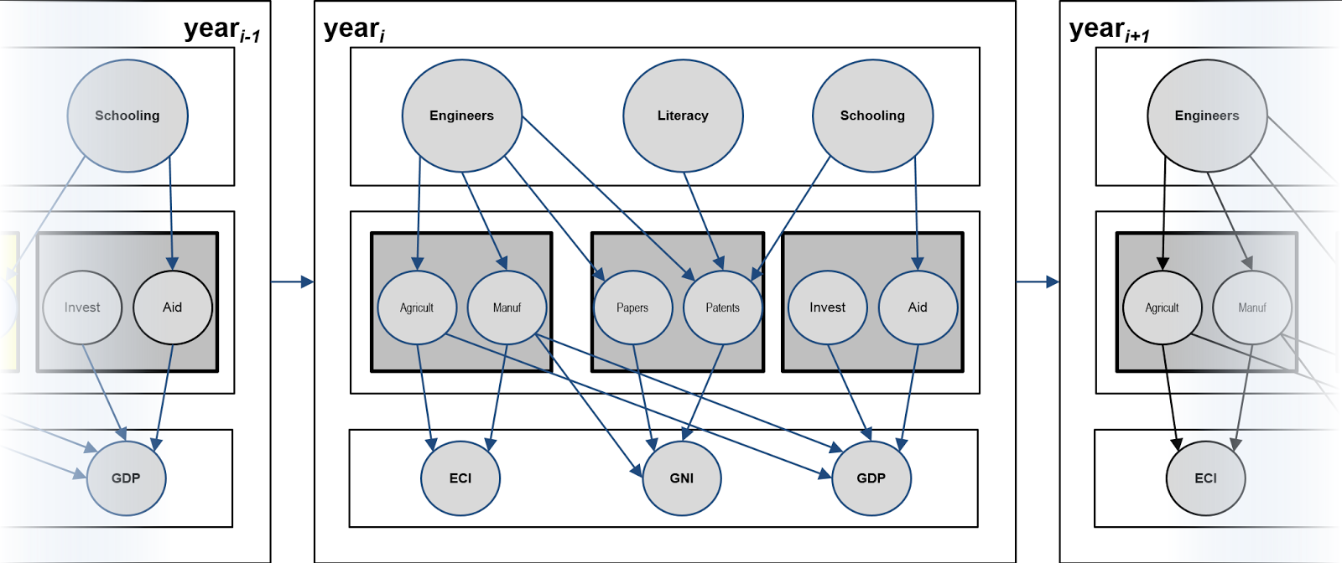
Fig.5: Proposed system flowchart
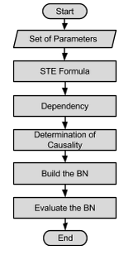
We first select the variables with which to build the network. Then, using the domain knowledge model, calculate the STE values for all relevant pairs. We select the greatest value to determine dependency, and then test for agreement against the domain knowledge model to determine causality. This gives us a graph from which we build a Bayesian network, which we then train and evaluate.

Bayesian Network structures

Bayesian Network#1: We depend on 9 rejons to predect the PPP (GDP of ….)

Afireca:
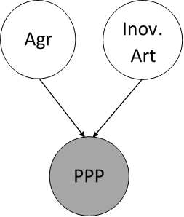

Middle East

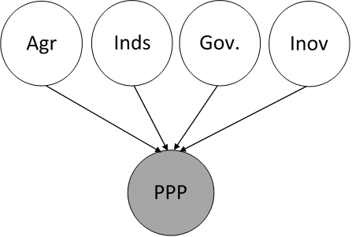

Europe
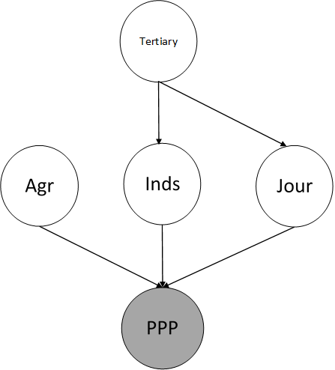

Ltin America

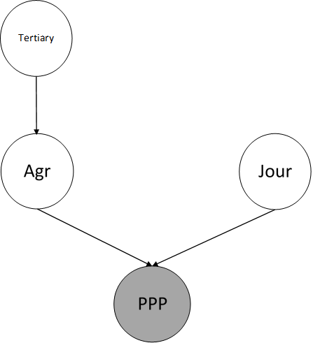

North America
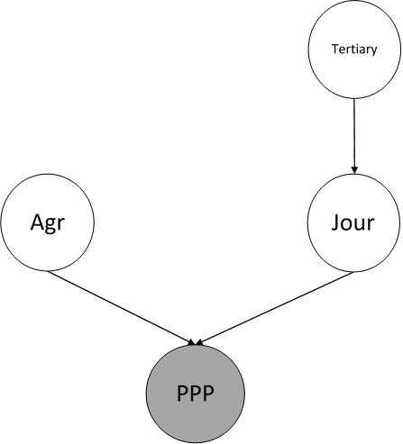

South Aisa
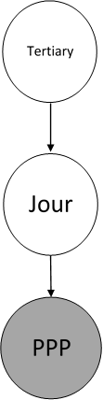

East Aisa
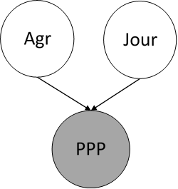

World
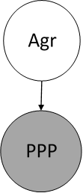

Bayesian Network#1: We depend on 9 rejons to predect the PPP

Afireca:
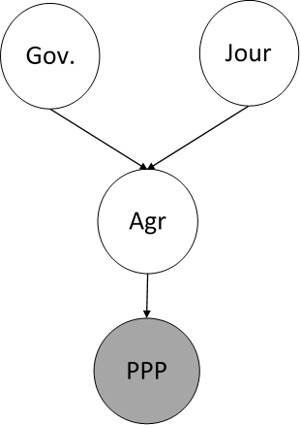

Middle East
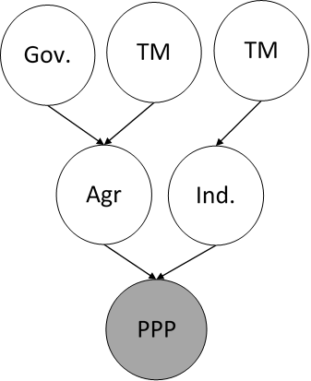

Europe
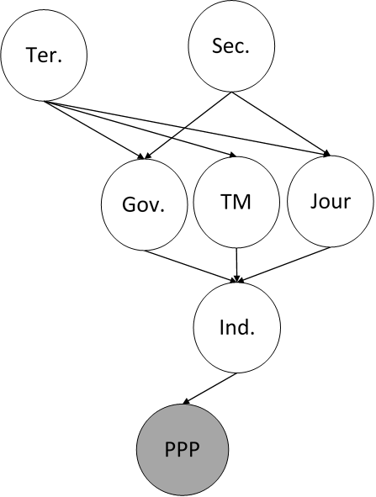

Ltin America
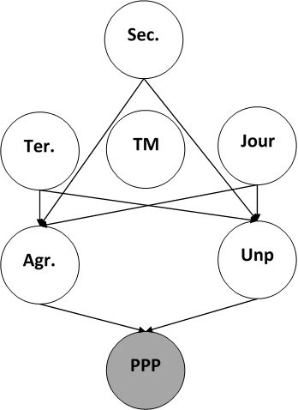

North America
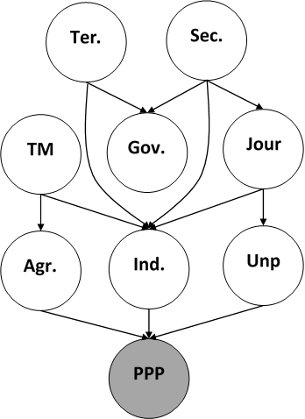

East Aisa
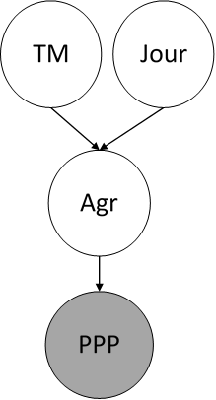

World
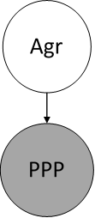

Challenges
There are a series of challenges this project will have to face. First, it seem unlikely that a single model can encompass all the countries in the world accurately. This is indeed strongly discouraged by Migiro. It is necessary, then, to subdivide the countries into regions or economic groups, and build a bayesian network for each.
However, this highlights the little data that is available: Although GDP data is available since 1962, some of the variables only have data collected for the 1992-2012 period. When using all 180 countries, that provides 3,600 data points for those variables, not counting missing values. Splitting the data will greatly reduce this number. A split is necessary not only to ensure greater accuracy, but also to perform cross-validation and testing. If we take a year as the test set, we will be removing up to 180 points from the dataset of each variable. However, if we take any one country at random to use as the test set, we will be removing from each variable as many data points as there are years, and might accidentally choose a country among which has weak relation captured by the given variables to construct the Bayesian network will lower the outcome predictability.
Furthering the challenge is that no one knows the distribution that most, if not all, of these variables follow. We will assume by general rules of statistics, that their distributions follow Gaussian.
Another challenge emerges from the scientific method itself: we have posited as our basic hypothesis that our method can build sound Bayesian networks, and set the prediction of economic indicators as our experiment. If the Bayesian networks that result are reasonable and accurate, we will be able to say our hypothesis has support. However, if our bayesian networks are not good, it does not falsify our hypothesis, and therefore gives us no real information on our approach.
Finally, our use of domain knowledge requires us to discard information that “makes no sense”. Because we will be building the networks manually, we may observe that this information is actually useful, and raises the question of whether its absence will hinder the network, and how to incorporate it to test for this hinderance, if at all.

References
- Bokova, I in UNESCO. (2010). “Foreword.” Engineering: Issues, Challenges and Opportunities for Development UNESCO Report. http://unesdoc.unesco.org/images/0018/001897/189753e.pdf
- Chickering, D. and D. Heckerman. (Jul 31 1997) “Scalable Methods for Learning Bayesian Networks”. Microsoft Corporation (assignee). Patent 7,251,636. http://patentimages.storage.googleapis.com/pdfs/US7251636.pdf
- Cooper, G. and Herskovits, E. (Oct 1992) “A Bayesian Method for the Induction of Probabilistic Networks from Data.” Machine Learning. Volume 9, Issue 4, pp 309-347. Springer International. http://link.springer.com/article/10.1007%2FBF00994110
- Drahokoupil, J. “Investment incentive.” (May 30 2013) Encyclopædia Britannica Online. Encyclopædia Britannica Inc, http://www.britannica.com/EBchecked/topic/1929166/investment-incentive.
- Friedman, N., Nachman, I., Peér, D., (1999) “Learning of Bayesian Network Structure from Massive Datasets: The ‘Sparse Candidate’ Algorithm.” UAI'99 Proceedings of the Fifteenth conference on Uncertainty in artificial intelligence, pp 206-215. http://dl.acm.org/citation.cfm?id=2073820.
- Helman, P., Veroff, R., Atlas, S., and Willman, C. (January 20, 2005) “A Bayesian Network Classification Methodology for Gene Expression Data.” Journal of Computational Biology, Vol. 11, Issue 4. http://online.liebertpub.com/doi/abs/10.1089/cmb.2004.11.581 .
- Hausmann, R., Hidalgo, C., Bustos, S., Coscia, M., Chung, S., Jiménez, J. S.,Simoes, A., and Yıldırım, M.. (2011). The Atlas of Economic Complexity - Mapping paths of prosperity. Boston: Center for International Development - Harvard University.
- ITEP. (Aug 14, 2013) “Tax Incentives: Costly for States, Drag on the Nation.” ITEP Reports. Institute on Taxation and Economic Policy. http://itep.org/itep_reports/2013/08/tax-incentives-costly-for-states-drag-on-the-nation.php.
- Jaffe, K., Rios, A., & Florez, A. (Nov 5 2012). Statistics shows that economic prosperity needs both high scientific productivity and complex technological knowledge, but in different ways. SSRN Working papers.
- Microsoft. (Jan 18 2007). Excel statistical functions: STEYX. Microsoft Knowledge Base. http://support.microsoft.com/kb/828232.
- Migiro, A. (Jun 16 2010) “No ‘one size fits all’ approach to development.” UN News Center. http://www.un.org/apps/news/story.asp?NewsID=35048.
- Mora, J, Torre, F, and Torre, F. (May 22 2013) “Contribución de la enseñanza de la ingeniería a la generación de conocimiento productivo”. Memorias del IV Congreso Iberoamericano de Enseñanza de la Ingeniería. Asociación Iberoamericana de Instituciones Enseñanza de la Ingeniería. Barquisimeto, Lara, Venezuela. ISBN: 978-980-6526-01-3.
- Raykie, J (2014). Education Funding Decision Dogs Gov. Corbett. The Herald Sharon (2014). http://www.sharonherald.com/news/education-funding-decision-dogs-gov-corbett/article_42721152-6236-11e4-b5d4-170cc5bcbb52.html.
- Russell, S, and Norvig, P. (2010) “A method for constructing Bayesian Networks.” Artificial Intelligence: A Modern Approach. Third Edition. §14.2.1.1. Pearson Education.
- Shapcott, M., Sterritt, R., Adamson, K., and Curran, E. (1999) “NETEXTRACT - Extracting Belief Networks in Telecommunications Data.” The Pennsylvania State University. http://citeseerx.ist.psu.edu/viewdoc/summary?doi=10.1.1.28.6865.
- UNESCO. (2010). Engineering: Issues, Challenges and Opportunities for Development UNESCO Report. Unesco. http://unesdoc.unesco.org/images/0018/001897/189753e.pdf.
- World Bank. (2015) World Bank Open Data. World Bank Group. http://data.worldbank.org.
- Zady, M. “Correlation and Simple Least Squares Regression” (Aug 2000) Westgard QC. https://www.westgard.com/lesson42.htm.

